**Appendix S1. Detailed description of the abundance model using mark-resight data and overall population counts from drone-derived orthomosaics.**

Using the mark-resight data and the overall counts, we developed a novel modelling approach to estimate the total abundance of aggregated populations while accounting for the following sources of variation:

1. Open population: individuals enter the sandbank for the first time on different days throughout the nesting event and they can visit the sandbank more than once before nesting. After nesting, individuals do not return to the sandbank.
2. Individual states: an individual can be in either of two states in a given day: walking or nesting. Individuals walking are typically exploring the sandbank and can return in another day, and nesting individuals are usually sunken in the sand and do not return to the sandbank in subsequent days.
3. Unavailability: an individual that is part of the population (i.e., an individual that already entered the population and did not leave) can be outside the sandbank (e.g., in the water) during the drone flight and therefore can be unavailable for detection.
4. Double counts: some individuals that are walking during the flight can appear more than once in the same orthomosaic.
5. Unidentified marks: it may not be possible to identify some individual marks because of sand over these marks.

The proposed modeling approach has two components; one for each data type (Figure 1). The first component is a multi-state open-population capture-recapture model for the mark-resight data that was adapted to include the probability of identifying the mark of an individual and the proportion of double counts. The second component models the dynamics in the overall population counts using the parameters estimated in the first part to estimate the total population size.

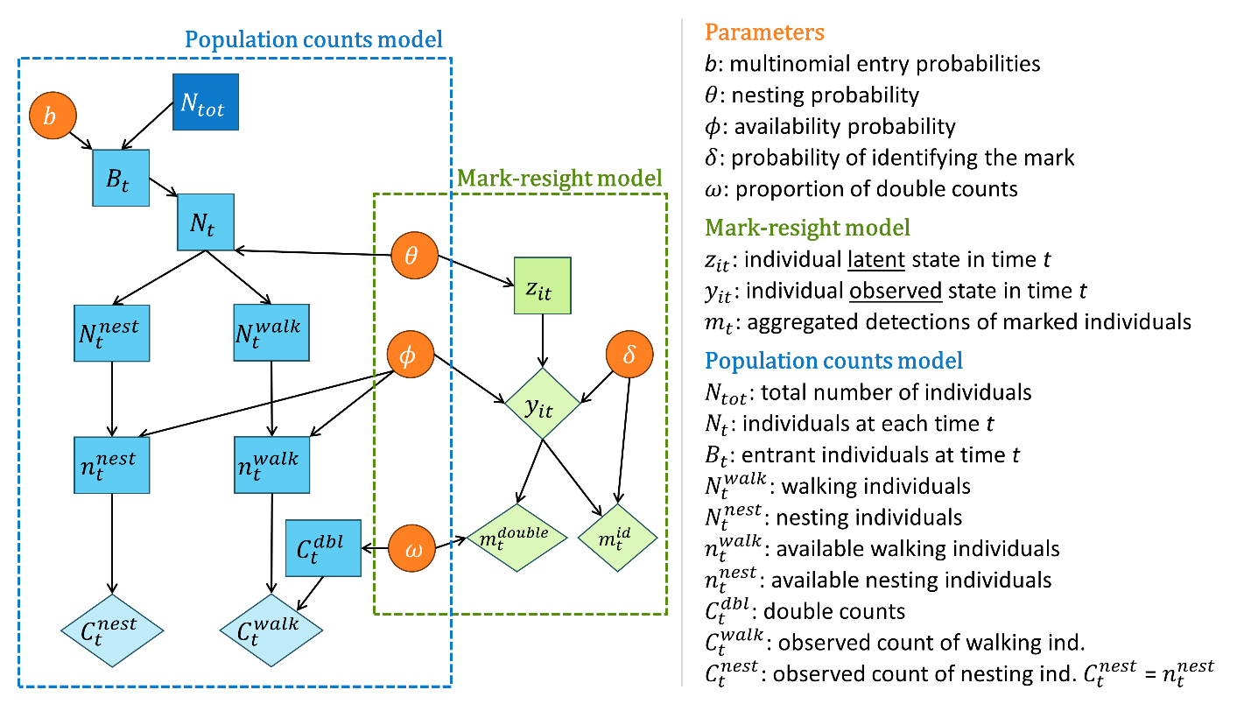

**Figure 1.** Directed acyclic graph for the combined modelling approach to estimate abundance from orthomosaic population counts and mark-resight data. Observed data, latent variables, and parameters are shown as diamonds, rectangles, and circles, respectively. Individual level mark-resight data are used to estimate parameters associated with the detection process and temporal dynamics of the overall population. The overall population counts are used to estimate the total population size and the parameters associated with the entry process.

*Mark-resight model*

We marked $M=1187$ turtles throughout the $T=12$ surveying days, during the night before the drone flights. For each marked individual $i∈\left\{1,2,…,M\right\}$, we recorded the first occasion (day) $t∈\{1,2,…,T\}$ that it was marked ${fo}_{i}$. Recall that an individual can go to the sandbank multiple times until nesting, and after nesting it leaves the area and does not return. Then, following the first capture (i.e., for $t≥{fo}_{i}$.), we considered that each individual can be in one of three different latent states at each occasion: $z_{it}=1$, walking/exploring (i.e., not nesting); $z_{it}=2$, nesting; and $z_{it}=3$, left the area (already nested). The probability of an individual to nest on each occasion *t* is defined as $θ$. Thus, the probability of an individual transitioning from the state $z_{i(t-1)}$ to the state $z_{it}$ is given by:

$$z_{it}|z_{i\left(t-1\right)}=k \sim Categorical(ψ_{k})$$

where $ψ_{k}$ is a vector defining the transition probabilities given that the individual is in the k-th state at time *t*-1. These vectors, when put together, make up the following transition matrix $Ψ$:

$$Ψ= \left[\begin{matrix}1-θ & θ & 0 \\ 0 & 0 & 1 \\ 0 & 0 & 1\end{matrix}\right]$$

The first row of this matrix indicates that an individual that is walking (i.e., has not nested yet) can remain walking in the next time step with probability $1-θ$ or can nest with probability $θ$. The second row of this matrix indicates that an individual that has nested in time t will necessarily leave the area at time *t*+1. Finally, the third row shows that an individual that has left the area will remain in this state in subsequent time steps.

Since we cannot directly observe the true state that the individual is in each day, we modeled the detection process for each observed state (given the true latent state): $y_{it}=1$, detected walking; $y_{it}=2$, detected nesting; and $y_{it}=3$, not detected (after its first capture). Let $ϕ$ and $δ$ be the probability of an individual being available in the sandbank area during the drone flight and the probability of identifying the mark of an available individual, respectively. Thus, each observation is given by:

$$y_{it}|z_{it}=k \sim Categorical(ρ_{k})$$

where $ρ_{k}$ is a vector of detection probabilities associated with latent state *k*. These vectors are combined into the following detection matrix $P$:

$$P= \left[\begin{matrix}ϕδ & 0 & \left(1-ϕ\right)+ϕ\left(1-δ\right) \\ 0 & ϕδ & \left(1-ϕ\right)+ϕ\left(1-δ\right) \\ 0 & 0 & 1\end{matrix}\right]$$

The first and second rows of this matrix indicate that an individual that is in the latent states walking ($z_{it}=1$) or nesting ($z_{it}=2$) will be detected as a result of two processes: the probability of being available during flight $ϕ$ and the probability of having its mark identified $δ$. Thus, a walking or nesting individual will not be identified because either it is not available ($1-ϕ$) or it is available but its mark was not identified $ϕ\left(1-δ\right)$. Finally, the third row indicates that an individual that has already left the population (latent state $z_{it}=3)$ will necessarily be undetected.

For the turtle data, we separated the availability process into two different parameters: i) $ϕ_{1}$: probability of an individual that was marked during the night (i.e., at 3 am) to still be available for detection in the sandbank during the sunrise flight at 6 am in the same day (i.e., for $t={fo}_{i}$); and ii) $ϕ_{2}$: probability of an individual that was marked in one day and did not nest yet to be available for detection in a following day.

The probability of identifying an available marked individual $δ$ is estimated using additional information. More specifically, in each orthomosaic *t*, we tallied the number of marked individuals that have identifiable marks $m_{t}^{id}$ or that have unidentifiable marks $m_{t}^{unid}$ to estimate $δ$:

$$m_{t}^{id}\sim Binomial(\left[m_{t}^{id}+m_{t}^{unid}\right], δ)$$

We also used the mark-resight data to estimate the proportion of double counts for the individuals detected as walking. We defined the total number of detections of marked individuals with identifiable marks walking in each orthomosaic as $m_{t}^{walk}$, and the number of these detections that correspond to double counts (i.e., repeated appearances) as $m_{t}^{double,walk}$. Then we estimated the proportion of double counts $ω$ as:

$$m_{t}^{double,walk} \sim Binomial(m_{t}^{walk}, ω)$$

*Population counts model*

Let $N_{tot}$ be the number of female turtles that uses the sandbank at least once during a period of $T=12$ sampling occasions. Each individual of the total population $N_{tot}$ has a probability $b_{t}$ of entering the population in occasion *t* so that:

$$B\sim Multinomial\left(N_{tot}, b\right)$$

where $B$ is a vector containing the number of individuals newly arrived in the area, $\sum_{t=1}^{T}{B_{t}=N_{tot}}$, and $\sum_{t=1}^{T}{b_{t}}=1$. The dynamics in the number of turtles per occasion ($N_{t}$) is governed by the number of individuals entering the population ($B_{t}$) and the number of individuals that were walking in the previous time step and that therefore stayed in the population ($N_{t-1}^{walk}$):

$$N_{1}=B_{1}$$

$N_{t}=N_{t-1}^{walk}+B_{t}$ (for $t>1$)

To determine the number of individuals walking at a particular time step $N_{t}^{walk}$, we assume that:

$$N_{t}^{nest} \sim Binomial\left(N_{t}, θ\right)$$

where $θ$ is the nesting probability and $N_{t}^{nest}$ is the number of individuals nesting. Therefore,

$$N_{t}^{walk}=N_{t}- N_{t}^{nest}$$

The population counts in the orthomosaics $C_{t}^{tot}$ is comprised of two observed components: number of detected individuals nesting ($C_{t}^{nest}$) and number of detected individuals walking ($C_{t}^{walk}$). We assumed that the number of nesting individuals that are available in the sandbank is perfectly observed ($C_{t}^{nest}=n_{t}^{true,nest}$) while the number of walking individuals detected is composed of the true number of unique walking individuals available ($n_{t}^{true,walk}$) and the number of double counts of walking individuals ($C_{t}^{double}$). As a result, $C_{t}^{tot}$ is given by:

$$C_{t}^{tot}=C_{t}^{nest}+C_{t}^{walk}= n_{t}^{true,nest}+\left[n_{t}^{true,walk}+C_{t}^{double}\right]$$

The number of unique individuals nesting and walking available in the sandbank during the flight is determined by the availability probability $ϕ$:

$n_{t}^{true,nest}\sim Binomial\left(N_{t}^{nest}, ϕ\right)$

$$n_{t}^{true,walk}\sim Binomial\left(N_{t}^{walk}, ϕ\right)$$

The number of walking individuals that correspond to double counts is a proportion of the total number of observed walking individuals:

$$C_{t}^{double}\sim Binomial\left(C_{t}^{walk},ω\right)$$

Recall that $θ,ϕ, and ω$ are estimated using the mark-resight data, allowing the population count data to inform the entry probabilities $b_{t}$ (i.e., the remaining population dynamics parameters).

We used vague priors for all the parameters: a Dirichlet distribution for the entry probabilities $b\sim Dirich(1)$, uniform distributions for all the other probabilities $U(0, 1)$, and $U(0, 200000)$ for the total abundance $N_{tot}$.

*Model fitting*

We conducted the analysis using a two-step approach under a Bayesian framework using the Nimble package in R. We first estimated the parameters for the mark-resight data, and then included these estimates to model the overall counts. In the first step, we ran three parallel Monte Carlo Markov chains (MCMC) with 120,000 steps from which the first 20,000 were discarded (burn-in). This resulted in 300,000 samples of the posterior distribution.

An initial exploration with simulated data revealed that the proposed model had convergence issues. We were able to solve this by relying on the use of an estimable parameter when specifying transition probabilities for a nesting individual ($z_{it}|z_{i(t-1)}=2$). More specifically, instead of $ψ_{2}=\left[\begin{matrix}0 & 0 & 1\end{matrix}\right]$, we included an extra parameter $π$, yielding $ψ_{2}=\left[\begin{matrix}0 & 1-π & π\end{matrix}\right]$. We used a strong prior for $π$ (i.e., $π \sim Beta\left(20,1\right)$) to ensure that this parameter was very close to one.

In the second step, we randomly selected 881 posterior samples of each parameter estimated in step 1, fitted an independent analysis of the model to each of these samples, and then joined the posterior samples of each analysis to get the final estimates with uncertainty propagated. For the analysis of each sample from the first step, we ran three parallel chains with 40,000 steps, 20,000 burned-in, keeping one at every 100 samples. By combining all the 600 posterior samples of the 881 analyses, we ended up with a total of 528,600 posterior samples for the parameters of the second step. We assessed model convergence by visual inspection of the chains’ traceplots and using R-hat statistics.